THE lab OF Cité des bébés

PRESENTATION OF THE LAB
Book tickets
Starting from January 3, 2022, the afternoon hours will be from 2:30 to 5:30 p.m., still without booking. The mornings remain on slot booking from 10am to 12pm.
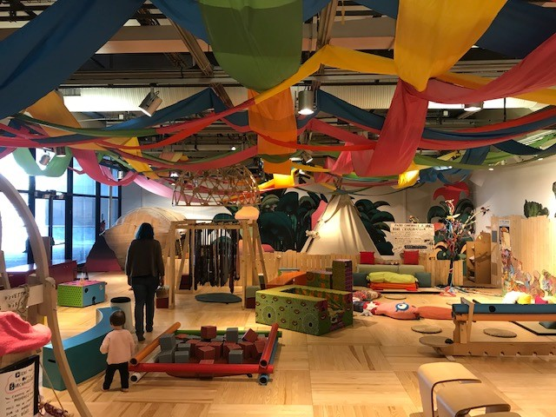

For the comfort of toddlers, the Cité des bébés Lab is restricted to babies only, from 0 to 23 months, supervised by an adult (two maximum). Children under 18 are not considered as accompanying adults and cannot access the Lab.
Children aged 2 and over will find their happiness in the Cité des enfants 2/7 years or 5/12 years, in the Fragile! temporary exhibition (for 2/6 years), in the Bibliothèque jeunesse (Children’s library) (open from 12:00) or at the aquarium (free access during the Cité des sciences et de l'Industrie's opening hours).

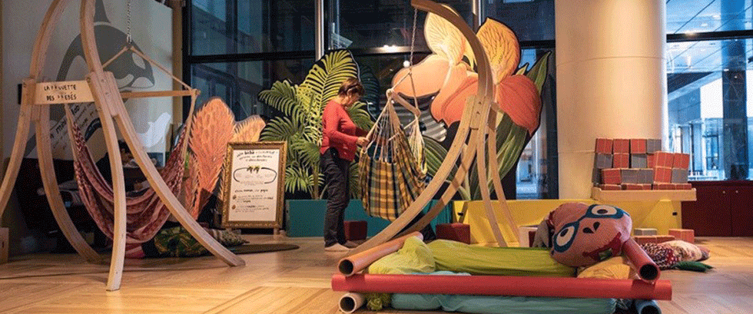
Designed as a secure nest, the Cité des bébés lab encourages the cognitive and psychomotor development of babies.
This warm space is an opportunity for babies, families and professionals to meet.
An experimental area to prepare together the Cité des bébés of tomorrow!
Activities adapted to toddlers
Everything is done to help babies open their eyes to the world around them and to stimulate their motor and cognitive skills. The playful atmosphere is enriched throughout the year by workshops adapted to toddlers (story tales and theatrical readings, sign language activities, etc.).
Eco-responsible space
Floor, walls, games, cuddly toys... the space is deliberately plastic-free and screen-free!
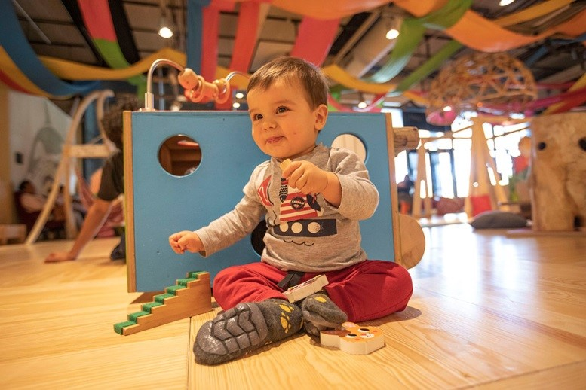

A quiet and restful space
Armchairs and cushions are available for breastfeeding and rest.

Informations and discussions on early childhood
Specialised books on child psychology, education and health for young children are available at the Bibliothèque (Library) and the Cité de la Santé.
Scientists and specialists in early childhood will be regularly invited to discuss openly with adults and answer their questions.
With the associations Joue Pense Parle (speech and language therapist) et la crapahutte (psychomotricians)
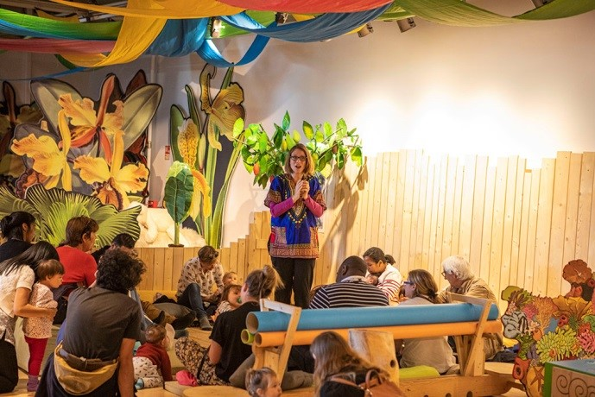
The space can accommodate a maximum of 45 people, including babies and accompanying adults. Babies must be supervised by one or two adults.
The lab is a shoes-free and phone-free space.

Why I turn off my phone (pdf, 1.7 Mo in french)

Workshops for toddlers

During certain sessions, you can take part in an activity specifically designed for toddlers.

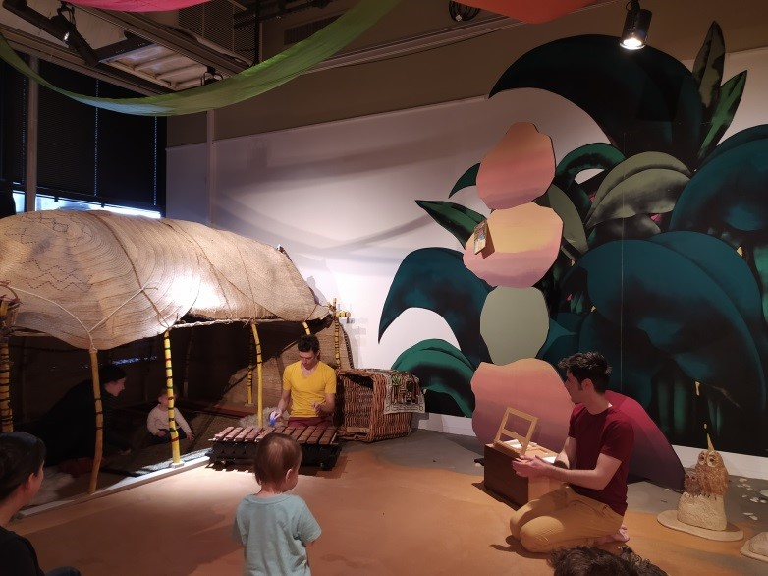 Rebondire compagny, Albums and rhymes on the road

Workshops are regularly offered during the opening hours of the Cité des bébés' lab.

The scientific education team of the Cité des bébés lab offers shows, animated stories and discovery activities adapted to toddlers.

We have prepared some activities to do at home with your baby inspired by those shown in the Lab.

